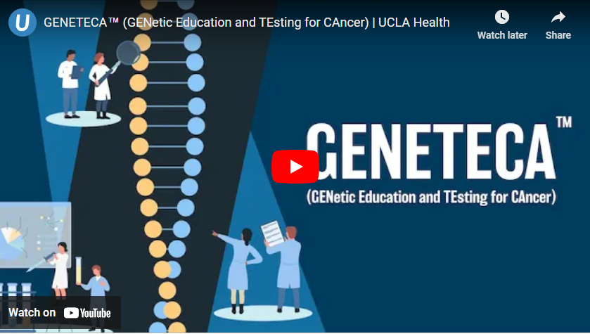

https://www.uclahealth.org/cancer/cancer-services/cancer-genetics/video-library

